

عنوان البحث

........................................................................................................................................................................

|  |  |
| --- | --- |
| كلـــــــــــــــية | : الهندسة الالكترونية بمنوف |
| القســم/الشعبة | :عام |
| الفرقـة/المستوي | :الأولى |
| اســــم المقـــرر | :Computer Organization |
| كــــود المقــــرر | :--------------- |
| اســـــم الطالب | :عبدالرحمن عمادالدين محمد الشافعي |
| الرقـــم القومي | :30004301700253 |
| البريد الأكاديمي | :ab.al.shafei@el-eng.menofia.edu.eg |
| اشـــــــــــــراف | : أ.د./ محمد عبده محمد بربار |

**Abstract**

A Microprocessor is an important part of a computer architecture without which you will not be able to perform anything on your computer. It is a programmable device that takes in input perform some arithmetic and logical operations over it and produce desired output. In simple words, a Microprocessor is a digital device on a chip which can fetch instruction from memory, decode and execute them and give results.

**Introduction**

A microprocessor is a computer processor that incorporates the functions of a central processing unit on a single (or more) integrated circuit (IC) of MOSFET construction. The microprocessor is a multipurpose, clock driven, register based, digital integrated circuit that accepts binary data as input, processes it according to instructions stored in its memory and provides results (also in binary form) as output. Microprocessors contain both combinational logic and sequential digital logic. Microprocessors operate on numbers and symbols represented in the binary number system.

The integration of a whole CPU onto a single or a few integrated circuits using Very-Large-Scale Integration (VLSI) greatly reduced the cost of processing power. Integrated circuit processors are produced in large numbers by highly automated metal-oxide-semiconductor (MOS) fabrication processes, resulting in a low unit price. Single-chip processors increase reliability because there are many fewer electrical connections that could fail. As microprocessor designs improve, the cost of manufacturing a chip (with smaller components built on a semiconductor chip the same size) generally stays the same according to Rock's law.

**Research Project Contents**

**8085 microprocessor Architecture:**

8085 is pronounced as "eighty-eighty-five" microprocessor. It is an 8-bit microprocessor designed by Intel in 1977 using NMOS technology. Fig 1 shows the architecture of 8085.

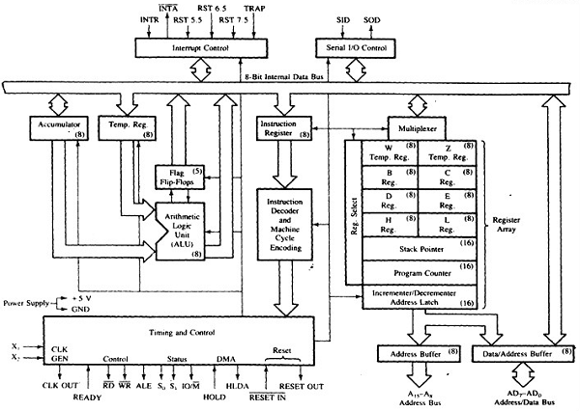

Fig 1 architecture of 8085

It has the following configuration:

1. 8-bit data bus
2. 16-bit address bus, which can address up to 64KB
3. A 16-bit program counter
4. A 16-bit stack pointer
5. Six 8-bit registers arranged in pairs: BC, DE, HL
6. Requires +5V supply to operate at 3.2 MHZ single phase clock

It is used in washing machines, microwave ovens, mobile phones, etc.

**8085 Microprocessor – Functional Units:**

8085 consists of the following functional units −

1. Accumulator

It is an 8-bit register used to perform arithmetic, logical, I/O & LOAD/STORE operations. It is connected to internal data bus & ALU.

1. Arithmetic and logic unit

As the name suggests, it performs arithmetic and logical operations like Addition, Subtraction, AND, OR, etc. on 8-bit data.

1. General purpose register

There are 6 general purpose registers in 8085 processor, i.e. B, C, D, E, H & L. Each register can hold 8-bit data. These registers can work in pair to hold 16-bit data and their pairing combination is like B-C, D-E & H-L.

1. Program counter

It is a 16-bit register used to store the memory address location of the next instruction to be executed. Microprocessor increments the program whenever an instruction is being executed, so that the program counter points to the memory address of the next instruction that is going to be executed.

1. Stack pointer

It is also a 16-bit register works like stack, which is always incremented/decremented by 2 during push & pop operations.

1. Temporary register

It is an 8-bit register, which holds the temporary data of arithmetic and logical operations.

1. Flag register

It is an 8-bit register having five 1-bit flip-flops, which holds either 0 or 1 depending upon the result stored in the accumulator. These are the set of 5 flip-flops:

* Sign (S)
* Zero (Z)
* Auxiliary Carry (AC)
* Parity (P)
* Carry (C)

Its bit position is shown in the following table:

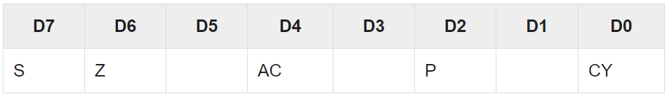

1. Instruction register and decoder

It is an 8-bit register. When an instruction is fetched from memory then it is stored in the Instruction register. Instruction decoder decodes the information present in the Instruction register.

1. Timing and control unit

It provides timing and control signal to the microprocessor to perform operations. Following are the timing and control signals, which control external and internal circuits:

* Control Signals: READY, RD’, WR’, ALE
* Status Signals: S0, S1, IO/M’
* DMA Signals: HOLD, HLDA
* RESET Signals: RESET IN, RESET OUT

1. Interrupt control

As the name suggests it controls the interrupts during a process. When a microprocessor is executing a main program and whenever an interrupt occurs, the microprocessor shifts the control from the main program to process the incoming request. After the request is completed, the control goes back to the main program. There are 5 interrupt signals in 8085 microprocessors: INTR, RST 7.5, RST 6.5, RST 5.5, TRAP.

1. Serial Input/output control

It controls the serial data communication by using these two instructions: SID (Serial input data) and SOD (Serial output data).

1. Address buffer and address-data buffer

The content stored in the stack pointer and program counter is loaded into the address buffer and address-data buffer to communicate with the CPU. The memory and I/O chips are connected to these buses; the CPU can exchange the desired data with the memory and I/O chips.

1. Address bus and data bus

Data bus carries the data to be stored. It is bidirectional, whereas address bus carries the location to where it should be stored, and it is unidirectional. It is used to transfer the data & Address I/O devices.

**6502 microprocessors:**

The MOS Technology 6502 (typically "sixty-five-oh-two" or "six-five-oh-two")[3] is an 8-bit microprocessor that was designed by a small team led by Chuck Peddle for MOS Technology. Fig 2 shows the architecture of 6502 microprocessor.

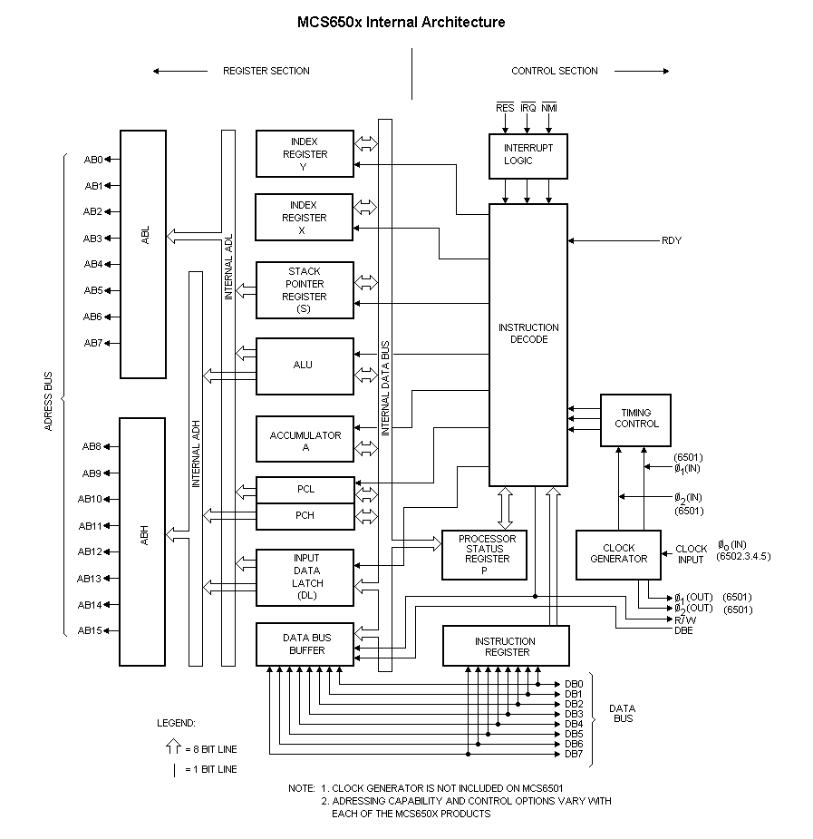

Fig 2 architecture of 6502 microprocessor.

1. The Registers

The 6502 has only a small number of registers compared to other processor of the same era. This makes it especially challenging to program as algorithms must make efficient use of both registers and memory.

1. Program Counter

The program counter is a 16 bit register which points to the next instruction to be executed. The value of program counter is modified automatically as instructions are executed.

The value of the program counter can be modified by executing a jump, a relative branch or a subroutine call to another memory address or by returning from a subroutine or interrupt.

1. Stack Pointer

The processor supports a 256 byte stack located between $0100 and $01FF. The stack pointer is an 8 bit register and holds the low 8 bits of the next free location on the stack. The location of the stack is fixed and cannot be moved. Pushing bytes to the stack causes the stack pointer to be decremented. Conversely pulling bytes causes it to be incremented. The CPU does not detect if the stack is overflowed by excessive pushing or pulling operations and will most likely result in the program crashing.

1. Accumulator

The 8 bit accumulator is used all arithmetic and logical operations (with the exception of increments and decrements). The contents of the accumulator can be stored and retrieved either from memory or the stack. Most complex operations will need to use the accumulator for arithmetic and efficient optimization of its use is a key feature of time critical routines.

1. Index Register X

The 8 bit index register is most commonly used to hold counters or offsets for accessing memory. The value of the X register can be loaded and saved in memory, compared with values held in memory or incremented and decremented. The X register has one special function. It can be used to get a copy of the stack pointer or change its value.

1. Index Register Y

The Y register is similar to the X register in that it is available for holding counter or offsets memory access and supports the same set of memory load, save and compare operations as wells as increments and decrements. It has no special functions.

1. Processor Status

As instructions are executed a set of processor flags are set or clear to record the results of the operation. This flags and some additional control flags are held in a special status register. Each flag has a single bit within the register. Instructions exist to test the values of the various bits, to set or clear some of them and to push or pull the entire set to or from the stack.

* Carry Flag
* Zero Flag
* Interrupt Disable
* Decimal Mode
* Break Command
* Overflow Flag
* Negative Flag

**National Semiconductor SC/MP:**

National Semiconductor's Simple Cost-effective Micro Processor or SC/MP (pronounced scamp) is an early microprocessor which became available in early 1974. It features a 16-bit address and an 8-bit data bus. The program counter is twelve bits wide, and there are separate instructions to set the upper four bits of the program counter, which are subsequently output on the address bus, along with status signals. This provides a memory map of sixteen four-kilobyte pages. Internally it provided five registers plus the program counter, but no stack pointer. Fig 3 shows NSC microprocessor configuration.

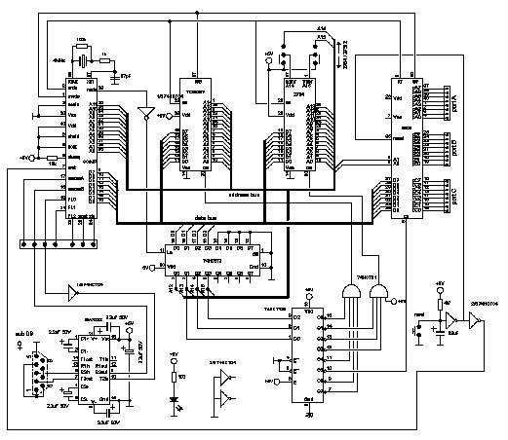

Fig 3 NSC microprocessor architecture

An advanced and unusual feature for the time, is the ability to release the buses, so that they can be shared by multiple processors. The linked datasheet shows an implementation with three SC/MP in a multi-processor configuration. SC/MP increments the program counter before fetching the instruction, so that on reset it starts executing instructions from location 0001. This also needs to be considered for calculating displacements, since the offset will be added to the program counter which will be still pointing to the location of the displacement and not the next instruction. To minimize chip count in control applications it has dedicated serial input and output pins to allow implementation of serial communications in software without the need for a UART (this feature was removed in the later SC/MP III). ISP-8A/500 SC/MP-1 Clocked at 1 MHz, first implementation (P Channel MOS technology). INS 8060 ISP-8A/600 SC/MP-2 Clocked at 4 MHz (internally 2 MHz) first N Channel MOS version (single +5V supply). INS 807x SC/MP-3 Clocked at 4 MHz (internally 2 MHz) included variations with up to 4 KB ROM (optional onboard BASIC (NIBL).

**References**

Write the references of the research project in this part.

1. Suszko, S. F. "NSC 800, 8-bit CMOS microprocessor." (1984).
2. Choi, G. S., Iyer, R. K., & Carreno, V. A. (1990). Simulated fault injection: A methodology to evaluate fault tolerant microprocessor architectures. IEEE Transactions on Reliability, 39(4), 486-491.
3. 6502 Applications Book; 1st Ed; Rodnay Zaks; Sybex; 281 pages; 1979; ISBN 978-0895880154.
4. William Stallings Computer Organization and Architecture: Designing for Performance 8th Ed. Prentice Hall, 2009 ISBN 0-13-607373-5.
5. Tanenbaum, Andrew S. "Structured computer organization." (2006).